Christian Education Classes 2018
Updated September 2018

Introduction to Christian Education

Subject matter for each class has been specifically identified to help develop faith in, and knowledge of, our Lord and Savior. The format will be presented in four quarters through the year; several different classes will be offered each quarter, and class attendees will have an opportunity to learn from different instructors, meet new people in the different classes, and enjoy a variety of Biblically-based subject matter.
Philippians 1:9- And it is my prayer that your love may abound more and more, with knowledge
and all discernment...

This initiative is part of our Care, Connect and Challenge mission, making disciples who make disciples, and is consistent with the Micro Church program which is designed to encourage and
challenge believers to live out their faith and share
the Good News.

1 Peter 3:15- always be ready to give an answer to anyone who asks about the hope you possess.

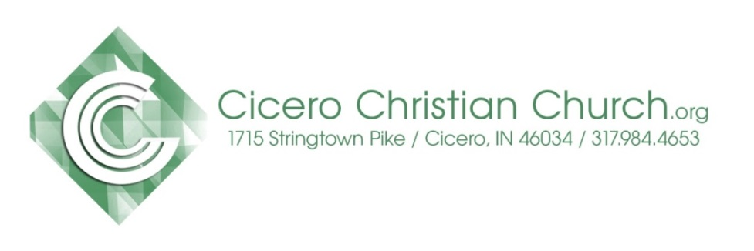

Table of Contents

September 30 ~ #cicerofam Community
Service Day
with NO Christian Education Classes

4th Quarter – Fall Courses
October 7 – December 23, 2018

- Study of John
- Getting to Know #cicerofam
- How to Read the Bible
- Christian Standard Bible Lesson Commentary
- Book of James
- Intimacy with the Almighty
- Financial Peace University
- Old Testament – What’s the Point? (1 day)

Map of Cicero Christian Church
Kids & Student Services
CCC Leadership & Support Staff

Christian Education Teachers

Heart of why you teach
Mike Jenkins - I believe that God has extended to me the spiritual gift of teaching for the purposes stated in Ephesians 4:11-12 & 1 Corithians 12:28. I have always found preparing to teach a lesson allows me to increase my knowledge and understanding, and I consider that a blessing. My goal in teaching is to Glorify God, impart knowledge, and require accountability for what has been taught.
Jim Doyle - I have a passion for developing people, particularly in discipleship and mentoring. I was a certified trainer of Situational Self Leadership for Ken Blanchard (One Minute Manager) Training & Development, and have developed and led numerous Bible studies, lectures and sermons.
Andy Gable - I consider it an honor to have a role in the discipleship process of other people. I enjoy teaching, not just to impart knowledge to others, but helping them process new learning in a way that leads to life change and a deeper connection to God and their neighbors.
John Knapp – I have enjoyed teaching SS for years the first thing I do is to pray for the Holy Spirit to guide and direct me that I will be able to reach out and touch someone with the Word of God.

Gino Small - The words of Paul in Romans 1 describes for me the reason I take time to facilitate in a classroom setting. Romans 1:11-12, “ I long to see you so that I may impart to you some spiritual gift to make you strong-that is, that you and I may be mutually encouraged by each other’s faith.”

Keith Schoettmer - I’ve been teaching Sunday school at Cicero Christian Church for over 10 years. I love the challenge of keeping class interesting and sharing God's word with other Christians, regardless of where they are in their walk. I firmly believe that the only way we can truly appreciate and understand the heart of Christ is to dive into His word with regular, disciplined study.
Tom Strauss - I feel that God has placed in my heart a passion for financial issues. Since becoming a Christian in 1998, I’ve been seeking God’s will for my own finances. I feel He has used the circumstances in my life to give me something unique to share. To me, it’s only natural that I would share what I’ve learned. The Bible contains over 2,000 verses that deal with money and possessions. There’s a reason He talks about it so much: many people, including Christians, struggle with their finances. God knew this would be true, and said that “no one can serve two masters; for either he will hate the one and love the other, or he will be devoted to one and despise the other. You cannot serve God and wealth” (Matthew 6:24, NASB). But most of us don’t realize the importance He places on this area of our lives. My passion is to help change that.

Fall Quarter Oct. 7-Dec. 23, 2018
Study of John
Led by: Mike Jenkins & Jim Doyle
9a – first service in room 107
Summary of the Class
The Gospel of John is unique from the other gospels about Jesus. Some have called it "the heart of Christ". John’s primary theme is the deity of Jesus. He describes this in 16:28, "I came forth from the Father, and am come into the world; again, I leave the world, and go to the Father." God became a man; this is the simple statement of the powerful truth. Another key idea is believing that Jesus was the Messiah. John 20:31 says, “But these are written so that you may continue to believe that Jesus is the Messiah, the Son of God, and that by believing in him you will have life by the power of his name."

John employs a simple and understandable style. He presents a logical and chronological sequence of events, giving attention to naming places. While the deity of Christ is in the foreground, John also emphasizes the human side of Jesus (e.g. “Jesus...being wearied with his journey,” John 4:6). These details are recorded to instill faith in people’s hearts. Words such as believe and eternal life are used with much greater frequency and accentuate the uniqueness of John’s gospel in comparison to the other three gospel records.

Fall Quarter Oct. 7-28, 2018

Getting to Know #cicerofam
Led by: Andy Gable
9a – first service in room 133
Summary of the Class
This 4-week course introduces people to Cicero Christian Church and provides an overview of what matters most to our church and leadership team. It also gives some intentional next steps into discovering life with Jesus as well as what it means to be a part of the #cicerofam.

Week One: #whatweareabout
Discover our vision, mission, values, and strategy.

Week Two: #whatwebelieve
Discover our foundational beliefs.

Week Three: #joiningGod’sfam
Discover the next steps to a saving relationship with God.

Week Four: #joiningcicerofam
Discover the next steps of faith in Christ and serving alongside us here at CCC.

Fall Quarter Nov. 4- Dec. 23, 2018
Help me teach my friend….
How to Read the Bible

Led by: Gino Small
9- first service in room 133
Summary of the Class
Knowing and understanding God’s message of love, hope, and inspiration proclaimed through the Bible is essential for growing in our life with Jesus. For many people, as they begin reading the Bible, they find it difficult to understand the message without someone explaining it.
This course empowers you to learn how to read and understand the Bible for yourself and apply God’s truth to your life, but also enables you to teach others to do the same. One of the greatest gifts we can give someone is to help them learn to feed themselves spiritually through God’s word. Come learn the tools of the trade so that you can continue to pass them on.

Fall Quarter Oct. 7-Dec. 23, 2018
Standard Lesson Commentary

Led by: John Knapp
10:30a- second service in room 133
Summary of the Class
The Standard Lesson Quarterly surveys the Bible in six years, providing solid adult Bible study based on International Sunday School Lessons/Uniform Series. Each quarter contains 13 weeks of lessons, including verse-by-verse Bible exposition, discussion questions, and ready to use resources to enhance study.

Fall Quarter Oct. 7-Nov. 25, 2018
Book of James

Led by: Keith Schoettmer
10:30a- second service in room 107
Summary of the Class
The book of James is likely the first New Testament book written and is a remarkably straight forward guide to remaining faithful through trials and conflicts. The author, widely accepted as the half-brother of Jesus, encourages us to gain wisdom, strengthen our faith, and display our faith through obedience to God.
In this eight-week class we will study the text and apply it to our lives today. We will see the problems of human nature haven't changed in 2,000 years, but neither has God's word and His solutions to our sinful nature.

Fall Quarter Dec. 2-23, 2018
Intimacy with the Almighty

Led by: Andy Gable
10:30a- second service in room 107
Summary of the Class
During this 4-week course, we will look at how we can develop a lifestyle of prayer and grow in our intimacy with God. The four lessons center around four different spiritual practices that help us create greater space and awareness of God in and around our lives. We will also discover the wonderful truth that as we connect deeper with God, we are able to connect deeper with those around us. Whether you are a new believer or seasoned veteran, we are all called to continually deepen our connection to the Father.
This course will ask the questions:
How can I reorder the clutter in my life to encounter God deeper?
How do I create space to encounter God despite my whirlwind schedule?
How do I hear the still small voice of God amidst all the noise of life?
What areas of my life am I holding back and not yielding
to God?
Other Classes Offered
in the Fall Quarter
Financial Peace University

Led by: Tom Strauss
6:30p- starting Monday, Oct 15 in room 107
Summary of the Class
Financial Peace -- a DVD-based class on money taught by Dave Ramsey. Dave and his teaching team will walk you through the basics of budgeting, dumping debt, planning for the future, and much more. There will be some question/answer time after the DVD segment each week.
Cost of Course Scholarships are Available
Financial Peace – approx. $100/coupleThis is for CCC and the community. Child Care in provided if needed.

Old Testament – What’s the Point?

Led by: Adam Colter & Andy Gable
an one day class, tentative planned for Sat, Nov. 3 in room 107
Summary of the Class
Some people ask, “Why is it important to study the Old Testament since we are New Testament believers?” The answer is because the Old Testament scriptures were written to point us to Jesus. The Old Testament is filled with prophetic imagery, key leaders helping people connect to God in various ways, foreshadows of things to come, and a God hungry to reconnect with those he created. How do all these various parts work together to prepare us to recognize the coming Messiah (Jesus)?

This OT Survey course will examine how the Old Testament is shaped like a glove that only the hand of Jesus can fill. God took great care in crafting and shaping His relationship with humanity and particularly the family of Abraham (Israel) so that we would recognize His Son, sent to redeem the world. Join us for this 1-day class which reveals how the Old Testament answers some of our biggest questions about God and points to our greatest need - Jesus.

Next Gen Services

Kids: (Infants - Grades 5)
The Treehouse, birth through Kindergarten,
available both 9a & 10:30a
8:45a Sunday School
Grades 1-2 room 112 Grades 3-5 room 114
10:30a Worship
Clubhouse for grades 1-5, room 116/117
Students: (Grades 6 - 12)
8:45a No Sunday School
10:30a MvMnt for Students in grades 6-12, will worship in the Loft, room 218, upstairs

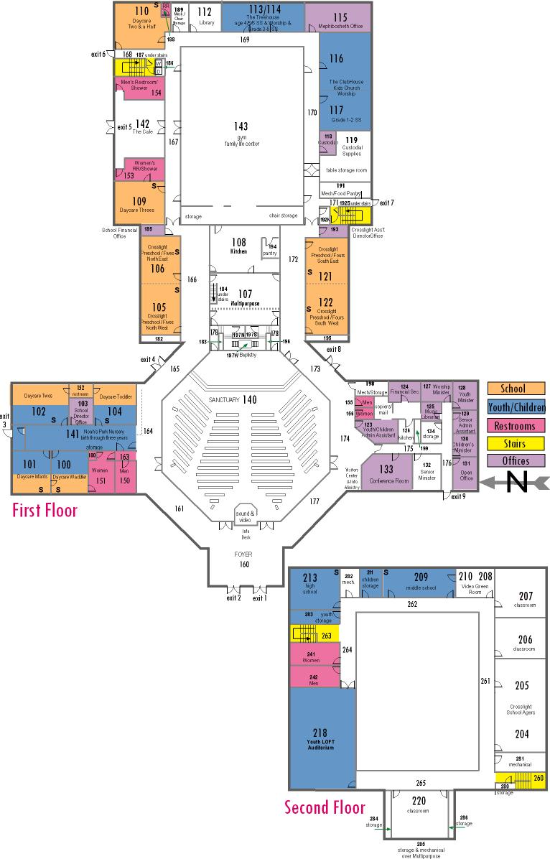
Map of CCC Classrooms

CCC Leadership & Support Staff

2018 Church Elders
Mark Fisher, cabinet chair…………….....…...…..317-984-2000
Mike House………………………………….…......317-439-9803
Dan Conder………………………...……….....…...317-758-6382
Jay St.Peters…………………………………….…317-450-3198
Keith Schoettmer…………….…………..……...…765-675-6822
Pastoral & Support Staff
Senior Pastor Adam Colter adam@cicerochristianchurch.org
Associate Pastor Andy Gable andy@cicerochristianchurch.org
Worship Pastor Dave Stroop dave@cicerochristianchurch.org
Associate Worship Pastor Zack Schuyler
Next Generation Director & High School Pastor Justin Pollock justin@cicerochristianchurch.org
Middle School Pastor Katie Smith
katie@cicerochristianchurch.org
Children’s Pastor & Administrative Assistant Amber Hawkins
amber@cicerochristianchurch.org
Next Generation Volunteer Coordinator Kristyn Cooper kristyn@cicerochristianchurch.org
Christian Counselor Charley Gerber
ccscharley@aol.com or 765-289-1631
Financial Secretary Sherry Strauss
sherry@cicerochristianchurch.org
Senior & Associate Pastor Administrative Asst. Jenni Roosa
jenni@cicerochristianchurch.org
Administrative Assistant Lisa Jamison lisa@cicerochristianchurch.org
Administrative Assistant Holly Eldredge

