Development
Course Catalog
2017
Updated September 14, 2017

Introduction to Development Courses

Subject matter for each class has been specifically identified to help develop faith in, and knowledge of, our Lord and Savior. The format will be presented in four quarters through the year; several different classes will be offered each quarter, and class attendees will have an opportunity to learn from different instructors, meet new people in the different classes, and enjoy a variety of Biblically-based subject matter.
Philippians 1:9- And it is my prayer that your love may abound more and more, with knowledge
and all discernment...

This initiative is part of our Care, Connect and Challenge mission, making disciples who make disciples, and is consistent with the Micro Church program which is designed to encourage and
challenge believers to live out their faith and share
the Good News.

1 Peter 3:15- always be ready to give an answer to anyone who asks about the hope you possess.

Table of Contents

4th Quarter – Fall Courses Offered
October 1 – December 17, 2017

- Overcoming: A Study of Job
- New to CCC? Origins and Essentials: Who We Are and What We Believe
- Amazing Grace: Forgiving your Offenders
- Standard Bible Lesson Commentary

Financial Peace University is being offered to
CCC and the community on Mondays at 6:30p.
Class starts October 16th. Sign up on our website
or through the church office.

Map of Cicero Christian Church
Kids & Student Services
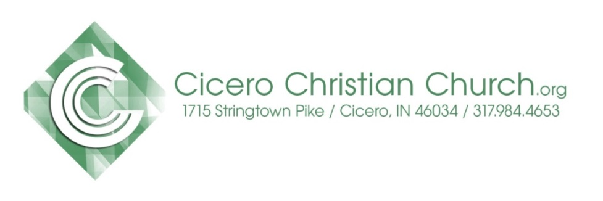
CCC Leadership & Support Staff

Development Course Teachers

Heart of why you teach
Keith Schoettmer - I’ve been teaching Sunday school at Cicero Christian Church for over 10 years. I love the challenge of keeping class interesting and sharing God's word with other Christians, regardless of where they are in their walk. I firmly believe that the only way we can truly appreciate and understand the heart of Christ is to dive into His word with regular, disciplined study.
Jim Doyle: I have a passion for developing people, particularly in discipleship and mentoring. I was a certified trainer of Situational Self Leadership for Ken Blanchard (One Minute Manager) Training & Development, and have developed and led numerous Bible studies, lectures and sermons. Kathy and I worked in a ministry partnership for over forty years with Cursillo, Tres Dias, Great Banquet, Walk to Emmaus and other discipleship kickoff ministries to fulfill a call to build the church up for works of service. And...I love to teach.

Steven Hancock - I teach in order to help people follow Jesus joyfully, passionately and full-throttle.

Mike Jenkins - I believe that God has extended to me the spiritual gift of teaching for the purposes stated in (Eph 4:11-12 & 1 Cor 12:28). I have always found preparing to teach a lesson allows me to increase my knowledge and understanding, and I consider that a blessing. My goal in teaching Sunday school is to Glorify God, impart knowledge, and require accountability for what has been taught.
Gino Small - The words of Paul in Romans 1 describes for me the reason I take time to facilitate in a classroom setting. Romans 1:11-12, “ I long to see you so that I may impart to you some spiritual gift to make you strong-that is, that you and I may be mutually encouraged by each other’s faith.”
John Knapp – I have enjoyed teaching SS for years the first thing I do is to pray for the Holy Spirit to guide and direct me that I will be able to reach out and touch someone with the Word of God.

Fall Quarter Oct. 1 – Dec. 17, 2017
Overcoming: A Study of Job
Led by: Keith Schoettmer & Jim Doyle
9a – first service in room 107
Summary of the Class
Job’s plight of undeserved suffering compels us to ask the age-old question, “Why do bad things happen to good people?” The answer given to Job may or may not satisfy the reader. God allows pain for good reason, but He may never reveal those reasons to us this side of heaven.
This study will delve into issues near to the heart of every human who experiences suffering. The prologue provides a fascinating peek into the back story—why God allowed Satan to afflict Job with such pain and turmoil. Then, through a series of dialogues and monologues, human wisdom attempts to explain the unexplainable, until finally God Himself speaks.
The final chapters of Job record God’s masterful defense of His majesty and unique supremacy above all creation—in contrast with Job’s humble and uninformed mortality. God asks Job, “Where were you when I laid the foundation of the earth? Tell Me, if you have understanding.” (Job 38:4).
Pain and suffering inevitably afflict each one of us in this life. Will your relationship with God be enough when trials come? Will you trust Him and His goodness through your suffering? We will explore these questions in application to our own lives.

Fall Quarter Oct. 1 – Dec. 17, 2017

Origins and Essentials: Who We Are & What We Believe

Led by: Gino Small & Mike Jenkins
9a –first service in room 133
Summary of the Class
We will study the GOSPEL -Christ's gift/our response- and how Cicero Christian Church has followed, and will continue to follow, its principles.
A 12 week course discovering more about CCC
Week 1 - CCC History
Week 2 – Restoration Movement
Week 3 – Vision, Mission, Strategy, Values
Week 4 – CCC Fundamentals
Week 5 – Deity, Death and Resurrection of Jesus
Week 6 – Hear
Week 7 – Confess
Week 8 – Baptism
Week 9 – Repentance
Week 10 – Walk with Christ
Week 11 – Spiritual Gifts
Week 12 – Serving God at CCC

Fall Quarter Oct. 1 – Dec. 17, 2017
Amazing Grace: Forgiving your Offenders

Led by: Steven Hancock
10:30a- second service in room 107
Summary of the Class
The greatest freedom is knowing you are completely forgiven by Christ for all your offenses and that you have completely forgiven all your offenders. People want to know how they can be certain that they have forgiven everyone. Highly practical, this course helps you understand how to apply grace to the fundamental issues of life.

Fall Quarter Oct. 1 – Dec. 17, 2017
Standard Lesson Commentary

Led by: John Knapp
10:30a- second service in room 122
Summary of the Class
The Standard Lesson Quarterly surveys the Bible in six years, providing solid adult Bible study based on International Sunday School Lessons/Uniform Series. Each quarter contains 13 weeks of lessons, including verse-by-verse Bible exposition, discussion questions, and ready to use resources to enhance study.

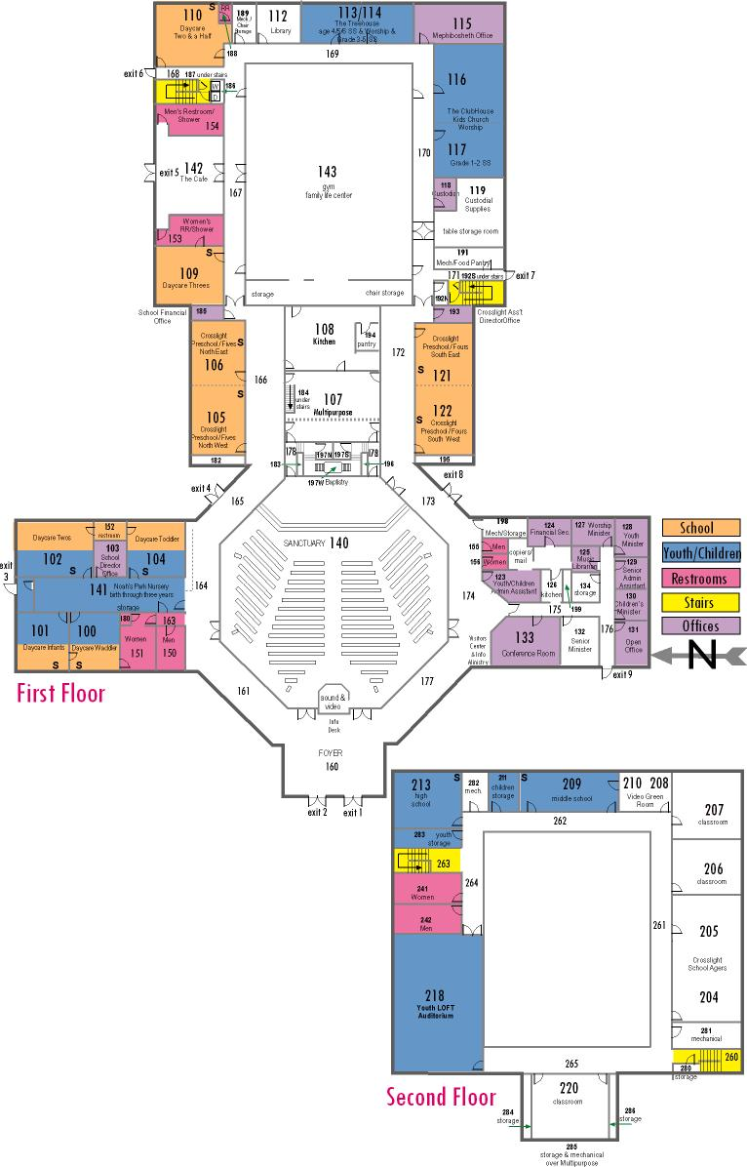
Map of CCC Classrooms

Next Gen Services

Kids: (Infants - Grades 5)
Noah’s Park Nursery, birth through Kindergarten, available both 9a & 10:30a
8:45a Sunday School
Grades 1-2 room 117
Grades 3-5 room 114
10:30a Worship
Clubhouse for grades 1-5, room 116/117
Students: (Grades 6 - 12)
8:45a No Sunday School
10:30a MvMnt for Students in grades 6-12, will worship in the Loft, room 218

CCC Leadership & Support Staff

2017 Church Elders
Mike Hutson, cabinet chair…………….....…..…..317-984-5743 Mike House………………………………….…......317-439-9803
Dan Conder………………………...……….....…...317-758-6382
Mark Fisher…………………………..........……….317-984-2000
Jay St.Peters…………………………………….…317-450-3198
Keith Schoettmer, mentoring…………..……...…765-675-6822
After-hours emergency calls (Pastor or Elder) 317-376-8222
Pastoral & Support Staff
Senior Pastor Adam Colter adam@cicerochristianchurch.org
Worship Pastor Dave Stroop dave@cicerochristianchurch.org
Next Generation Pastor Justin Pollock justin@cicerochristianchurch.org
Student Ministry Associate Katie Smith
katie@cicerochristianchurch.org
Next Generation Volunteer Coordinator Emma Roudebush emma@cicerochristianchurch.org
Christian Counselor Charley Gerber
ccscharley@aol.com or 765-289-1631
Financial Secretary
Sherry Strauss sherry@cicerochristianchurch.org
Senior Pastor Administrative Assistant
Jenni Roosa jenni@cicerochristianchurch.org
Children & Youth Pastor Administrative Assistant
Amber Hawkins amber@cicerochristianchurch.org
Worship Pastors Administrative Assistant
Lisa Jamison lisa@cicerochristianchurch.org

