Development
Course Catalog
2018
Updated December 14, 2017

Introduction to Development Courses

Subject matter for each class has been specifically identified to help develop faith in, and knowledge of, our Lord and Savior. The format will be presented in four quarters through the year; several different classes will be offered each quarter, and class attendees will have an opportunity to learn from different instructors, meet new people in the different classes, and enjoy a variety of Biblically-based subject matter.
Philippians 1:9- And it is my prayer that your love may abound more and more, with knowledge
and all discernment...

This initiative is part of our Care, Connect and Challenge mission, making disciples who make disciples, and is consistent with the Micro Church program which is designed to encourage and
challenge believers to live out their faith and share
the Good News.

1 Peter 3:15- always be ready to give an answer to anyone who asks about the hope you possess.

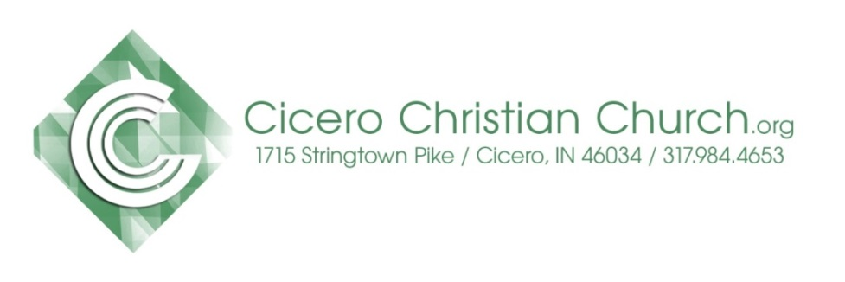

Table of Contents

1st Quarter – Winter Courses Offered
January 7 – March 25, 2018
- New to CCC? Origins and Essentials: Who We Are and What We Believe
- Study of Romans, Part I
- EntreLeadership (discipleship)
- Standard Lesson Commentary

Financial Peace University is being offered
2nd Quarter beginning April 23rd to CCC and
the community. Day and time to be announced.

April 1st ~ Easter – All Class Fellowship offered.

2nd Quarter – Spring Courses
April 8 – June 24, 2018

Map of Cicero Christian Church
Kids & Student Services
CCC Leadership & Support Staff

Development Course Teachers

Heart of why you teach
Keith Schoettmer - I’ve been teaching Sunday school at Cicero Christian Church for over 10 years. I love the challenge of keeping class interesting and sharing God's word with other Christians, regardless of where they are in their walk. I firmly believe that the only way we can truly appreciate and understand the heart of Christ is to dive into His word with regular, disciplined study.
Jim Doyle: I have a passion for developing people, particularly in discipleship and mentoring. I was a certified trainer of Situational Self Leadership for Ken Blanchard (One Minute Manager) Training & Development, and have developed and led numerous Bible studies, lectures and sermons. Kathy and I worked in a ministry partnership for over forty years with Cursillo, Tres Dias, Great Banquet, Walk to Emmaus and other discipleship kickoff ministries to fulfill a call to build the church up for works of service. And...I love to teach.
Gino Small - The words of Paul in Romans 1 describes for me the reason I take time to facilitate in a classroom setting. Romans 1:11-12, “ I long to see you so that I may impart to you some spiritual gift to make you strong-that is, that you and I may be mutually encouraged by each other’s faith.”

Mike Jenkins - I believe that God has extended to me the spiritual gift of teaching for the purposes stated in (Eph 4:11-12 & 1 Cor 12:28). I have always found preparing to teach a lesson allows me to increase my knowledge and understanding, and I consider that a blessing. My goal in teaching Sunday school is to Glorify God, impart knowledge, and require accountability for what has been taught.
John Knapp – I have enjoyed teaching SS for years the first thing I do is to pray for the Holy Spirit to guide and direct me that I will be able to reach out and touch someone with the Word of God.

Winter Quarter Jan. 7 – Mar. 25, 2018
Romans Part I
Led by: Keith Schoettmer & Jim Doyle
9a – first service in room 107
Summary of the Class
Paul's primary theme in Romans is the basic gospel, God's plan of salvation and righteousness for all mankind, Jew and Gentile alike. His purposes for writing this letter were (1) to present the basic system of salvation to a church that had not received the teaching of an apostle before, (2) to explain the relationship between Jew and Gentile in God's overall plan of redemption and (3) to prepare the way for his coming visit to Rome.
Paul shows how the believer is freed from sin, law and death, a provision made possible by his union with Christ in both death and resurrection, and by the indwelling presence of the Holy Spirit. He then shows that Israel too, though presently in a state of unbelief, has a place in God's sovereign redemptive plan. Currently she consists of only a remnant, allowing for the conversion of the Gentiles, but the time will come when "all Israel will be saved." (11:26) The letter concludes with an appeal to the readers to work out their Christian faith in practical ways, both in the church and in the world. None of Paul's other letters states so profoundly the content of the gospel and its implications for both the present and the future. It is one of the most complete theological themes on sin, salvation, grace, faith, righteousness, justification, sanctification, redemption, death and resurrection.
We will cover as much of these themes as is possible in 24 weeks, broken into the first two quarters of 2018. As we go, we will always discuss their applications for us today in the world in which we live.

Winter Quarter Jan. 7 – Mar. 25, 2018

Origins and Essentials: Who We Are & What We Believe

Led by: Gino Small
9a –first service in room 133
Summary of the Class
We will study the GOSPEL -Christ's gift/our response- and how Cicero Christian Church has followed, and will continue to follow, its principles.
A 12 week course discovering more about CCC
Week 1 - CCC History
Week 2 – Restoration Movement
Week 3 – Vision, Mission, Strategy, Values
Week 4 – CCC Fundamentals
Week 5 – Deity, Death and Resurrection of Jesus
Week 6 – Hear
Week 7 – Confess
Week 8 – Baptism
Week 9 – Repentance
Week 10 – Walk with Christ
Week 11 – Spiritual Gifts
Week 12 – Serving God at CCC

Winter Quarter Jan. 7 – Mar. 25, 2018
EntreLeadership (discipleship)
Led by: Mike Jenkins
10:30a – second service in room 107
Summary of the Class
Reviewing a successful formula for the blending of entrepreneurial skills with the corresponding skills needed to make an idea grow and prosper. There is a huge difference between starting an enterprise and leading one and even a larger difference between one that is valuable and one that has values. Ramsey’s thoughts are straight shooting, no-nonsense, faith-anchored work built upon godly principles. Ramsey gives us a playbook with principles that were discovered by experience and application of principles that he decided to consistently run every area of his life with a primary belief in the “golden rule” from scripture. That passage focuses on the “neighbor”. Scripture lists 81 passages in both the Old and New testaments that direct us in how to treat our neighbor. Jesus addressed it here:
Source: Dave Ramsey’s’ book entitled EntreLeadership, published by Howard Books, 2011 gives nuggets of wisdom, rooted in scripture and reflecting a biblical application into Mr. Ramsey’s 20 years of practical business wisdom from the trenches. There is a saying that a person cannot live long enough to make all the mistakes in life that will eventually make us successful so why not learn from the mistakes of others while being mindful of the guiding wisdom of God's Word? That is what Ramsey’s book does for us, helps us avoid the mistakes that cause failure. Failure is a great teacher but it is painful. Ramsey gives us some savvy heads-up information which is anchored in God's ’ Word.

Winter Quarter Jan. 7 – Mar. 25, 2018
Standard Lesson Commentary

Led by: John Knapp
10:30a- second service in room 133
Summary of the Class
The Standard Lesson Quarterly surveys the Bible in six years, providing solid adult Bible study based on International Sunday School Lessons/Uniform Series. Each quarter contains 13 weeks of lessons, including verse-by-verse Bible exposition, discussion questions, and ready to use resources to enhance study.

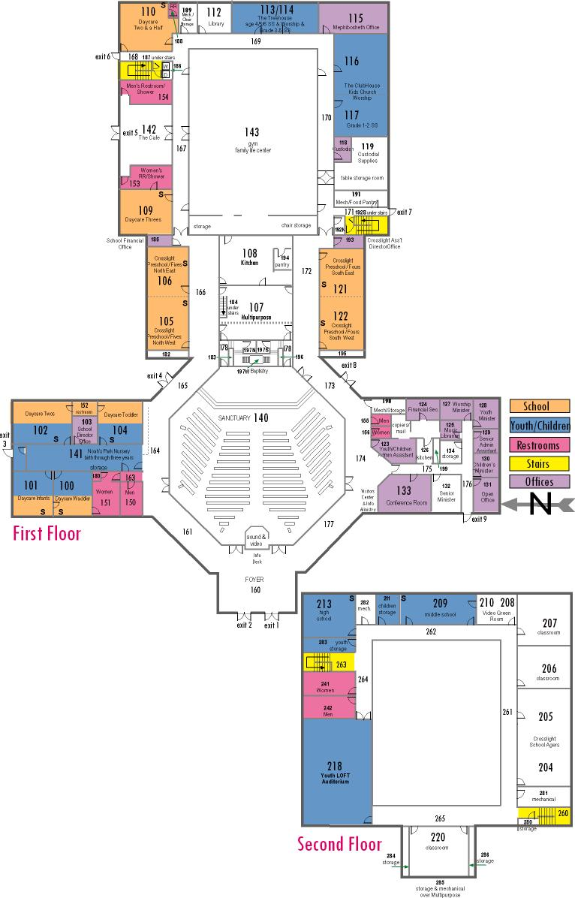
Map of CCC Classrooms

Next Gen Services

Kids: (Infants - Grades 5)
The Treehouse, birth through Kindergarten, available both 9a & 10:30a
8:45a Sunday School
Grades 1-2 room 117
Grades 3-5 room 114
10:30a Worship
Clubhouse for grades 1-5, room 116/117
Students: (Grades 6 - 12)
8:45a No Sunday School
10:30a MvMnt for Students in grades 6-12, will worship in the Loft, room 218

CCC Leadership & Support Staff

2017 Church Elders
Mike Hutson, cabinet chair…………….....…..…..317-984-5743 Mike House………………………………….…......317-439-9803
Dan Conder………………………...……….....…...317-758-6382
Mark Fisher…………………………..........……….317-984-2000
Jay St.Peters…………………………………….…317-450-3198
Keith Schoettmer, mentoring…………..……...…765-675-6822
After-hours emergency calls (Pastor or Elder) 317-376-8222
Pastoral & Support Staff
Senior Pastor Adam Colter adam@cicerochristianchurch.org
Worship Pastor Dave Stroop dave@cicerochristianchurch.org
Next Generation Pastor Justin Pollock justin@cicerochristianchurch.org
Student Ministry Associate Katie Smith
katie@cicerochristianchurch.org
Next Generation Volunteer Coordinator Emma Roudebush emma@cicerochristianchurch.org
Christian Counselor Charley Gerber
ccscharley@aol.com or 765-289-1631
Financial Secretary
Sherry Strauss sherry@cicerochristianchurch.org
Senior Pastor Administrative Assistant
Jenni Roosa jenni@cicerochristianchurch.org
Children & Youth Pastor Administrative Assistant
Amber Hawkins amber@cicerochristianchurch.org
Worship Pastors Administrative Assistant
Lisa Jamison lisa@cicerochristianchurch.org

